10.1.9 Editors - Shader Editor - Header - Add Menu - Texture
Detailed Table of content 1
Add menu - Texture 7
Brick Texture 7
Checker Texture 8
Environment Texture 8
Gradient Texture 9
IES Texture Node 10
Image Texture 11
Magic Texture 13
Musgrave Texture 14
Noise Texture 15
Point Density 16
Sky Texture 18
Voronoi Texture 19
Wave Texture 21
White Noise Texture 22

Detailed Table of content
Detailed table of content
Detailed Table of content 1
Add menu - Texture 7
Brick Texture 7
Inputs 7
Color 1, Color 2 and Mortar 7
Scale 7
Mortar Size 7
Mortar Smooth 7
Bias 7
Brick Width 7
Row Height 7
Properties 7
Offset 7
Frequency 7
Squash 7
Frequency 8
Outputs 8
Color 8
Factor 8
Checker Texture 8
Inputs 8
Vector 8
Color1, Color 2 8
Scale 8
Outputs 8
Color 8
Factor 8
Environment Texture 8
Inputs 8
Vector 8
Properties 9
Image 9
Color Space 9
Texture Interpolation 9
Linear 9
Closest 9
Cubic 9
Smart 9
Projection Method 9
Equirectangular 9
Mirror Ball 9
Outputs 9
Color 9
Gradient Texture 9
Inputs 10
Vector 10
Properties 10
Gradient Type 10
Linear 10
Quadratic 10
Easing 10
Diagonal 10
Spherical 10
Quadratic Sphere 10
Radial 10
Outputs 10
Color 10
Factor 10
IES Texture Node 10
Inputs 10
Vector 10
Strength 11
Properties 11
Mode 11
Internal 11
External 11
Outputs 11
Factor 11
Image Texture 11
Inputs 11
Vector 11
Properties 11
Image 11
Interpolation 12
Linear 12
Cubic 12
Closest 12
Smart 12
Projection 12
Flat 12
Box 12
Blend 12
Sphere 12
Tube 12
Extension 12
Repeat 13
Extend 13
Clip 13
Outputs 13
Color 13
Alpha 13
Magic Texture 13
Inputs 13
Vector 13
Scale 13
Distortion 13
Properties 13
Depth 13
Outputs 13
Color 13
Factor 13
Musgrave Texture 14
Inputs 14
Vector 14
W 14
Scale 14
Detail 14
Dimension 14
Lacunarity 14
Offset 14
Gain 14
Properties 14
Dimensions 14
1D 15
2D 15
3D 15
4D 15
Type 15
fBM (fractal Brownian Motion) 15
Multifractal 15
Hybrid Multifractal 15
Ridged Multifractal 15
Hetero Terrain (Heterogeneous Terrain) 15
Outputs 15
Factor 15
Noise Texture 15
Inputs 15
Vector 15
W 16
Scale 16
Detail 16
Roughness 16
Distortion 16
Properties 16
Dimensions 16
1D 16
2D 16
3D 16
4D 16
Outputs 16
Factor 16
Color 16
Point Density 16
Inputs 16
Vector 16
Properties 17
Point Data 17
Particle System 17
Object Vertices 17
Object 17
Particle System 17
Space 17
World Space 17
Object Space 17
Radius 17
Interpolation 17
Closest 17
Linear 17
Cubic 17
Resolution 17
Color Source 17
Particle Color Sources 17
Particle Age 17
Particle Speed 17
Particle Velocity 18
Vertex Color Sources 18
Vertex Color 18
Vertex Weight 18
Vertex Normals 18
Outputs 18
Color 18
Density 18
Sky Texture 18
Inputs 18
Vector 18
Properties 18
Sky Type 18
Sun Direction 18
Turbidity 18
Ground Albedo 19
Outputs 19
Color 19
Voronoi Texture 19
Inputs 19
Vector 19
W 19
Scale 19
Randomness 19
Properties 19
Dimensions 19
1D 19
2D 19
3D 19
4D 19
Feature 19
F1 19
Smooth F1 20
Distance To Edge 20
N-Sphere Radius 20
Distance Metric 20
Euclidean 20
Manhattan 20
Chebychev 20
Minkowski 20
Outputs 20
Distance 20
Color 20
Position 20
W 20
Radius 20
Wave Texture 21
Inputs 21
Vector 21
Scale 21
Distortion 21
Detail 21
Detail Scale 21
Detail Roughness 21
Phase Offset 21
Properties 21
Wave Type 21
Bands direction 21
Wave Profile 21
Saw 21
Sine 21
Triangle 21
Outputs 22
Color 22
Factor 22
White Noise Texture 22
Inputs 22
Vector 22
W 22
Properties 22
Dimensions 22
1D 22
2D 22
3D 22
4D 22
Outputs 22
Value 22

Add menu - Texture
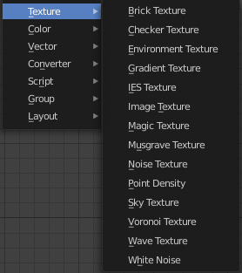
Here are the texture nodes. They allow you to add different texture types to the scene. The content is the same for the sub modes and the different renderers. However, a environment texture just makes sense for the world sub mode.

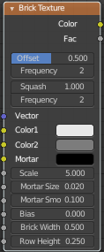
Brick Texture
The Brick Texture node is used to add a procedural brick texture.

Inputs

Color 1, Color 2 and Mortar
Color of the bricks and mortar.

Scale
Overall texture scale.

Mortar Size
The size of the filling between the bricks known as “mortar”; 0 means no mortar.

Mortar Smooth
Blurs/softens the edge between the mortar and the bricks. This can be useful with a texture and displacement textures.

Bias
The color variation between Color 1/2. Values of -1 and 1 only use one of the two colors; values in between mix the colors.

Brick Width
The width of the bricks.

Row Height
The height of the brick rows.

Properties

Offset
Determines the brick offset of the various rows.

Frequency
Determines the offset frequency. A value of 2 gives an even/uneven pattern of rows.

Squash
Amount of brick squashing.

Frequency
Brick squashing frequency.

Outputs

Color
Texture color output.

Factor
Mortar mask (1 = mortar).

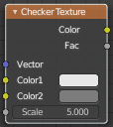
Checker Texture
The Checker Texture node adds a procedural checkerboard texture.

Inputs

Vector
Texture coordinate to sample texture at; defaults to Generated texture coordinates if the socket is left unconnected.

Color1, Color 2
Color of the checkers.

Scale
Overall texture scale. The scale is a factor of the bounding box of the face divided by the scale. For example, a scale of 15 will result in 15 alternate patterns over the overall UV bounding box. Different patterns could be achieved using other nodes to give different input patterns to this socket. For example, using the Math Node.

Outputs

Color
Texture color output.

Factor
Checker 1 mask (1 = Checker 1).

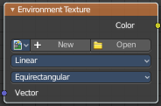
Environment Texture
Load an environment texture to light your scene.

Inputs

Vector
Texture coordinate for texture look-up. If this socket is left unconnected, the image is mapped as environment with the Z axis as up.

Properties

Image
Image data-block used as the image source. Additional settings can be found in Sidebar > Item > Properties: These include options to control the alpha channel along with addition options for the color space. These addition options are documented with the rest of Common Image Settings.

Color Space
Type of data that the image contains, either Color or Non-Color Data. For most color textures the default of Color should be used, but in case of e.g. a bump or alpha map, the pixel values should be interpreted as Non-Color Data, to avoid doing any unwanted color space conversions.

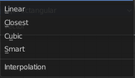
Texture Interpolation
Interpolation method used for the environment texture. The following interpolations are available:

Linear
Regular quality interpolation.

Closest
No interpolation, use closest pixel.

Cubic
Smoother, better quality interpolation.

Smart
Bicubic when magnifying, otherwise Bilinear is used. This is only available for OSL.

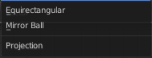
Projection Method
Allows you to use different types of environmental maps. The following methods are supported:

Equirectangular
Projection from an Equirectangular photo.

Mirror Ball
Projection from an orthographic photo or mirror ball.

Outputs

Color
RGB color from the image.

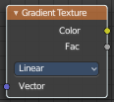
Gradient Texture

The Gradient Texture node generates interpolated color and intensity values based on the input vector.

Inputs

Vector
Texture coordinate to sample texture at; defaults to Generated texture coordinates if the socket is left unconnected.

Properties

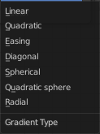
Gradient Type
Controls the type of gradient generated.

Linear
Directly returns the input X coordinate.

Quadratic
Interpolates the input X coordinate quadratically.

Easing
Uses a combination of quadratic and linear interpolation to return a smooth gradient from the input X coordinate.

Diagonal
Averages the input X and Y coordinates.

Spherical
Creates an inverse gradient using the length of the input vector; the maximum value is at (0, 0, 0).

Quadratic Sphere
The same as Spherical, except interpolated quadratically.

Radial
Returns a value based on the angle of the input around the Z axis.

Outputs

Color
Texture color output.

Factor
Texture intensity output.

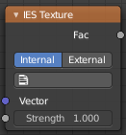
IES Texture Node
The IES Texture is used to match real world lights based on IES files. IES files store the directional intensity distribution of light sources.

Inputs

Vector
Texture coordinate for lookup in the light distribution. Defaults to the normal.

Strength
Light strength multiplier.

Properties

Mode

Internal
Use IES profile from a file embedded in a text data-block in the blend-file, for easy distribution.

External
Load IES profile from a file on the drive.

Outputs

Factor
Light intensity, typically plugged into the Strength input of an Emission node.

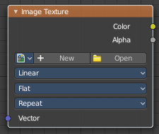
Image Texture
The Image Texture is used to add an image file as a texture.

Inputs

Vector
Texture coordinate for texture look-up. If this socket is left unconnected, UV coordinates from the active UV render layer are used.

Properties

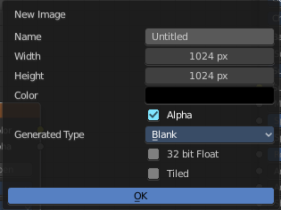
Image
Open an image, choose an existing image, or generate a new image.

When you click at Open then a file browser opens up. When you click at New then a popup dialog opens. up where you can create a new image.

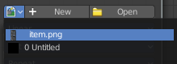
The image browser at the left allows you to pick an already existing texture from the scene.

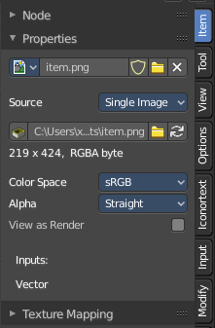
More image settings can be found in the Sidebar in the Items tab. Usually you find in the Item tab the very same settings like in the selected node. But the Image texture node is an exception. It shows here the usual image related settings too. This will be explained in the sidebar chapter.

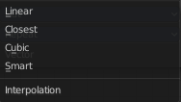
Interpolation
Method to scale images up or down for rendering.

Linear
Regular quality interpolation.

Cubic
Smoother, better quality interpolation. For bump maps this should be used to get best results.

Closest
No interpolation, use only closest pixel for rendering pixel art.

Smart
Cycles Only
Only for Open Shading Language. Use cubic interpolation when scaling up and linear when scaling down, for a better performance and sharpness.

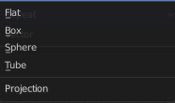
Projection
Projection to use for mapping the textures.

Flat
Uses the XY coordinates for mapping.

Box
Maps the image to the six sides of a virtual box, based on the normal, using XY, YZ and XYZ coordinates depending on the side.

Blend
For Box mapping, the amount to blend between sides of the box, to get rid of sharp transitions between the different sides. Blending is useful to map a procedural-like image texture pattern seamlessly on a model. 0.0 gives no blending; higher values give a smoother transition.

Sphere
Sphere mapping is the best type for mapping a sphere, and it is perfect for making planets and similar objects. It is often very useful for creating organic objects.

Tube
Maps the texture around an object like a label on a bottle. The texture is therefore more stretched on the cylinder. This mapping is of course very good for making the label on a bottle, or assigning stickers to rounded objects. However, this is not a cylindrical mapping so the ends of the cylinder are undefined.

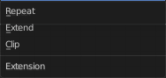
Extension
Extension defines how the image is extrapolated past the original bounds:

Repeat
Will repeat the image horizontally and vertically giving tiled-looking result.

Extend
Will extend the image by repeating pixels on its edges.

Clip
Clip to the original image size and set all the exterior pixels values to transparent black.

Outputs

Color
RGB color from image. If the image has alpha, the color is premultiplied with alpha if the Alpha output is used, and unpremultiplied or straight if the Alpha output is not used.

Alpha
Alpha channel from image.

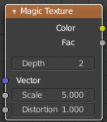
Magic Texture
The Magic Texture node is used to add a procedural psychedelic color texture.

Inputs

Vector
Texture coordinate to sample texture at; defaults to Generated texture coordinates if the socket is left unconnected.

Scale
Scale of the texture.

Distortion
Amount of distortion.

Properties

Depth
Number of iterations.

Outputs

Color
Texture color output.

Factor
Texture intensity output.

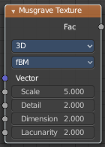
Musgrave Texture
The Musgrave Texture node evaluates a fractal Perlin noise at the input texture coordinates. Unlike the Noise Texture, which is also a fractal Perlin noise, the Musgrave Texture allows greater control over how octaves are combined.

Inputs
The available input types change, dependent of the chosen Type and dimensions.

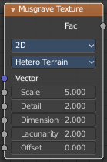
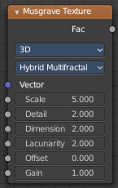
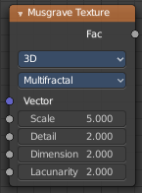
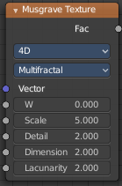

Vector
Texture coordinate to evaluate the noise at. Defaults to Generated texture coordinates if the socket is left unconnected.

W
Texture coordinate to evaluate the noise at. Appears with 4 dimensions.

Scale
Scale of the base noise octave.

Detail
Number of noise octaves. The fractional part of the input is multiplied by the magnitude of the highest octave. Higher number of octaves corresponds to a higher render time.

Dimension
The difference between the magnitude of each two consecutive octaves. Larger values corresponds to smaller magnitudes for higher octaves.

Lacunarity
The difference between the scale of each two consecutive octaves. Larger values corresponds to larger scale for higher octaves.

Offset
An added offset to each octave, determines the level where the highest octave will appear.

Gain
An extra multiplier to tune the magnitude of octaves.

Properties

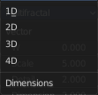
Dimensions
The dimensions of the space to evaluate the noise in.

1D
Evaluate the noise in 1D space at the input W.

2D
Evaluate the noise in 2D space at the input Vector. The Z component is ignored.

3D
Evaluate the noise in 3D space at the input Vector.

4D
Evaluate the noise in 4D space at the input Vector and the input W as the fourth dimension.

Higher dimensions corresponds to higher render time, so lower dimensions should be used unless higher dimensions are necessary.

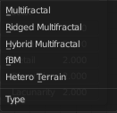
Type
Type of the Musgrave texture.

fBM (fractal Brownian Motion)
Produces an unnatural homogeneous and isotropic result. Uses an additive cascade, the values are simply added together.

Multifractal
The result is more uneven (varies with location), more similar to a real terrain. Uses a multiplicative cascade.

Hybrid Multifractal
Creates peaks and valleys with different roughness values, like real mountains rise out of flat plains. Combines the additive cascade with a multiplicative cascade.

Ridged Multifractal
Creates sharp peaks. Calculates the absolute value of the noise, creating “canyons”, and then flips the surface upside down.

Hetero Terrain (Heterogeneous Terrain)
Similar to Hybrid Multifractal creates a heterogeneous terrain, but with the likeness of river channels.

Outputs

Factor
Texture value.

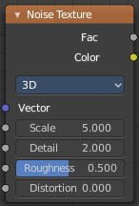
Noise Texture
The Noise Texture node evaluates a fractal Perlin noise at the input texture coordinates.

Inputs
The inputs are dynamic, they become available if needed depending on the node properties.

Vector
Texture coordinate to evaluate the noise at; defaults to Generated texture coordinates if the socket is left unconnected.

W
Texture coordinate to evaluate the noise at.

Scale
Scale of the base noise octave.

Detail
Number of noise octaves. The fractional part of the input is multiplied by the magnitude of the highest octave. Higher number of octaves corresponds to a higher render time.

Roughness
Adds a roughness noise.

Distortion
Amount of distortion.

Properties

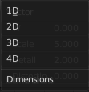
Dimensions
The dimensions of the space to evaluate the noise in.

1D
Evaluate the noise in 1D space at the input W.

2D
Evaluate the noise in 2D space at the input Vector. The Z component is ignored.

3D
Evaluate the noise in 3D space at the input Vector.

4D
Evaluate the noise in 4D space at the input Vector and the input W as the fourth dimension.

Outputs

Factor
Value of fractal noise.

Color
Color with different fractal noise in each component.

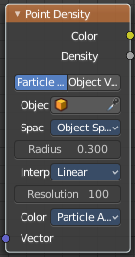
Point Density

The Point Density node is used to add volumetric points for each particle or vertex of another object.

Inputs

Vector
Texture coordinate to sample texture at; defaults to global position (Position output of Geometry node) if the socket is left unconnected.

Properties

Point Data
Where to get points from.

Particle System
Use each particle position from the specified particle system.

Object Vertices
Use each vertex position from the specified object.

Object
Which object’s vertices or particle system will be used.

Particle System
Particle positions from this system will be used.

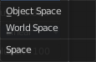
Space
The coordinate system for mapping points.

World Space
Map each point exactly where the source particle/vertex is.

Object Space
Fit the points from the source particles/vertices inside the bounding box of the object with the point density texture.

Radius
Size of the points.

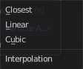
Interpolation
Texel filtering type.

Closest
No interpolation, use nearest texel. Produces blocky looking points.

Linear
Interpolate linearly between texels, producing soft, round points.

Cubic
Use cubic falloff, producing very soft points. Useful when points are very densely packed.

Resolution
The dimensions of the texture holding the point data.

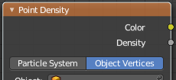
Color Source
Which attribute of the particle system or mesh is used to color the output. Switch to Object vertices to show the Vertex color sources.

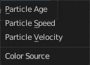
Particle Color Sources

Particle Age
Lifetime mapped as (0.0 - 1.0) intensity.

Particle Speed
Particle speed (absolute magnitude of velocity) mapped as (0.0 - 1.0) intensity.

Particle Velocity
XYZ velocity mapped to RGB colors.

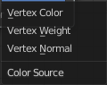
Vertex Color Sources

Vertex Color
Use a vertex color layer for coloring the point density texture.

Note. Vertex colors are defined per face corner. A single vertex can have as many different colors as faces it is part of. The actual color of the point density texture is averaged from all vertex corners.

Vertex Weight
Use weights from a vertex group as intensity values.

Vertex Normals
Use object-space vertex normals as RGB values.

Outputs

Color
Texture color output.

Density
Density of volume.

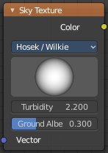
Sky Texture
The Sky Texture node adds a procedural Sky texture.

Inputs

Vector
Texture coordinate to sample texture at; defaults to Generated texture coordinates if the socket is left unconnected.

Properties

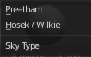
Sky Type
Sky model to use. You have the choice between two methods. Preetham and Hosek/Wilkie


Sun Direction
Sun direction vector. Click at the image and drag to change the sun direction.

Turbidity
Atmospheric turbidity. Some reference values:

2: Arctic like
3: clear sky
6: warm/moist day
10: hazy day

Ground Albedo
Amount of light reflected from the planet surface back into the atmosphere. (RGB(0, 0, 0) is black, RGB(1, 1, 1) is white.)

Outputs

Color
Texture color output.

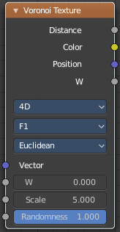
Voronoi Texture
The Voronoi Texture node evaluates a Worley Noise at the input texture coordinates.

Inputs
The inputs are dynamic, they become available if needed depending on the node properties.

Vector
Texture coordinate to evaluate the noise at; defaults to Generated texture coordinates if the socket is left unconnected.

W
Texture coordinate to evaluate the noise at.

Scale
Scale of the noise.

Randomness
The randomness of the noise.

Properties

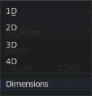
Dimensions
The dimensions of the space to evaluate the noise in.

1D
Evaluate the noise in 1D space at the input W.

2D
Evaluate the noise in 2D space at the input Vector. The Z component is ignored.

3D
Evaluate the noise in 3D space at the input Vector.

4D
Evaluate the noise in 4D space at the input Vector and the input W as the fourth dimension.

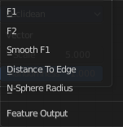
Feature
The Voronoi feature that the node will compute and return.

F1
Compute and return the distance to the closest feature point as well as its position and color.

Smooth F1
Compute and return a smooth version of F1.

Distance To Edge
Compute and return the distance to the edges of the Voronoi cells.

N-Sphere Radius
Compute and return the radius of the n-sphere inscribed in the Voronoi cells. In other words, it is half the distance between the closest feature point and the feature point closest to it.

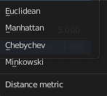
Distance Metric
The distance metric used to compute the texture.

Euclidean
Use the Euclidean distance metric.

Manhattan
Use the Manhattan distance metric.

Chebychev
Use the Chebychev distance metric.

Minkowski
Use the Minkowski distance metric. The Minkowski distance is a generalization of the aforementioned metrics with an Exponent as a parameter. Minkowski with an exponent of one is equivalent to the Manhattan distance metric. Minkowski with an exponent of two is equivalent to the Euclidean distance metric. Minkowski with an infinite exponent is equivalent to the Chebychev distance metric.

Outputs

Distance
The Distance.

Color
Cell color. The color is arbitrary.

Position
Position of feature point.

W
Position of feature point.

Radius
N-Sphere radius.

Note. In some configurations of the node, especially for low values of Randomness, rendering artifacts may occur. This happens due to the same reasons described in the Notes section in the White Noise Texture page and can be fixed in a similar manner as described there.

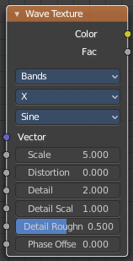
Wave Texture
The Wave Texture node adds procedural bands or rings with noise distortion.

Inputs

Vector
Texture coordinate to sample texture at; defaults to Generated texture coordinates if the socket is left unconnected.

Scale
Overall texture scale.

Distortion
Amount of distortion of the wave (similar to the Marble texture in Blender Internal).

Detail
Amount of distortion noise detail.

Detail Scale
Scale of distortion noise.

Detail Roughness
Adds a roughness noise.

Phase Offset
Set an offset for the phase.

Properties

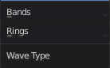
Wave Type
Bands or Rings shaped waves.

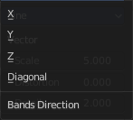
Bands direction
In which direction the bands should point.

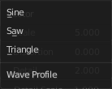
Wave Profile
Controls the shape and look of the wave type.

Saw
Uses a saw tooth profile.

Sine
Uses the standard sine profile.

Triangle
Uses a triangle shape.

Outputs

Color
Texture color output.

Factor
Texture intensity output.

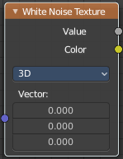
White Noise Texture
This node adds noise.

Inputs
The inputs are dynamic, they become available if needed depending on the node properties.

Vector
Vector used as seed in 2D, 3D, and 4D dimensions.

W
Value used as seed in 1D and 4D dimensions.

Properties

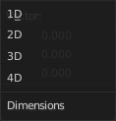
Dimensions
The dimensions of the space to evaluate the noise in.

1D
The W input is used as seed.

2D
The X and Y components of the Vector input are used as seed.

3D
The Vector input is used as seed.

4D
Both the Vector input and the W input are used as seed.

Outputs

Value
Output random value.

Note. The slightest difference in seed values would result in completely different outputs. Consequently, bad precision may have significant impact on the output. Usually, we can mitigate this issue by:

Eliminating the problematic seed value. If the problematic seed value is constant, it should be eliminated by choosing a lower dimension or multiplying it by zero.

Adding an arbitrary value to the seed. The issue might only happen at certain boundaries, like unit boundaries, so simply adding an arbitrary value might solve the issue.

Taking the absolute value of the seed. In computing, zero may be positive or negative, so taking the absolute values unifies the zero into a single value.

